**PROFORMA FOR THE APPROVAL PROJECT PROPOSAL**

***(Note: All entries of the proforma of approval should be filled up with appropriate and complete information. Incomplete proforma of approval in any respect will be summarily rejected.)***

PNR **No.: 2022016400270841** Roll no**: 757**

1. Name of the Student

**ANSHUKA RAVINDRA MAHAGAONKAR**

2. Title of the Project

**VINDER**

3. Name of the Guide

**MR. CHAYAN BHATTACHARJEE**

4. Teaching experience of the Guide

5. Is this your first submission? Yes No

Signature of the Student Signature of the Guide Date: ……24/8/24…………… Date: …………………….

Signature of the

Coordinator Date:

………………

**VINDER**

**A Project Report**

Submitted in partial fulfillment of the

Requirements for the award of the Degree of

**BACHELOR OF SCIENCE (INFORMATION TECHNOLOGY) By**

**MAHAGAONKAR ANSHUKA**

**RAVINDRA AKANKSHA**

**A-757**

**Under the esteemed guidance of**

**Prof. & Prof.**



**DEPARTMENT OF INFORMATION TECHNOLOGY**

**CHIKITSAK SAMUHA’S**

**S.S & L.S PATKAR COLLEGE OF ARTS & SCIENCE & V. P. VARDE COLLEGE OF COMMERCE & ECONOMICS.**

**An Autonomous College**

**Affiliated To University Of Mumbai**

**Goregaon (W), Mumbai – 400 062**

**CHIKITSAK SAMUHA’S**

**S.S & L.S PATKAR COLLEGE OF ARTS & SCIENCE & V. P. VARDE COLLEGE OF COMMERCE & ECONOMICS.**

**An Autonomous College**



**DEPARTMENT OF INFORMATION TECHNOLOGY**

**CERTIFICATE**

This is to certify that the project entitled, **"VINDER"**, is bonafide work of **ANSHUKA RAVINDRA MAHAGAONKAR** bearing Seat.No: 757 submitted in partial fulfillment of the requirements for the award of degree of BACHELOR OF SCIENCE in INFORMATION TECHNOLOGY from University of Mumbai.

**Internal Guide**

**Coordinator**

**External Examiner**

**Date: CollegeSeal**

**COMPANY CERTIFICATE** (ONLY FOR LIVE PROJECTS) IF APPLICABLE

T.Y.B.Sc Information Technology Semester V Anshuka Ravindra Mahagaonkar 757 4 | Page

**ABSTRACT**

The fast-paced nature of modern life often leaves individuals with little time to plan leisure activities, especially over weekends. **Vinder** is an innovative app designed to streamline the process of weekend planning by providing personalized recommendations for various spots and activities within the user's city. Leveraging user preferences and location data, **Vinder** suggests an array of options such as restaurants, parks, arcades, and movie theaters. To enhance user convenience, the app offers integrated booking and reservation features, allowing users to easily secure spots at their favorite venues. Additionally, **Vinder** enables users to plan their weekend activities in advance, up to a week ahead, making it easier to organize and enjoy leisure time. With curated lists, detailed information, and user reviews, **Vinder** aims to transform the weekend planning experience, making it enjoyable, effortless, and tailored to each user's unique tastes.

T.Y.B.Sc Information Technology Semester V Anshuka Ravindra Mahagaonkar 757 5 | Page

**ACKNOWLEDGEMENT**

We would like to express our heartfelt gratitude to all those who have contributed to the successful completion of this project.First and foremost, we extend our special thanks to Mr.Chayan Bhattacharjee ,whose mentorship and constructive feedback have been crucial in refining our project. Their expertise has been instrumental in shaping our work and pushing us toward excellence.We are thankful to our CEO, Dr. Mala Kharkar, and our Principal,

Dr. Pratibha Gaikwad, for providing us with the opportunity to undertake this

project and for fostering an environment that encourages learning and innovation. We are also grateful to Mrs. Namrata Kawale Shinde, our Chief Coordinator of Technology and Coordinator of Information Technology, for her invaluable insights and support that greatly enhanced our work. Additionally, we thank all our teaching and non-teaching staff for their constant support throughout this journey. We are also grateful to our colleagues, friends, and family members for their encouragement and belief in our abilities, which have motivated us throughout this process.This project is a testament to the collectiveeffortand dedication of everyone involved, and we are truly grateful for the contributions of each individual. Thank you all for making this project a fulfilling and rewarding experience.

T.Y.B.Sc Information Technology Semester V Anshuka Ravindra Mahagaonkar 757 6 | Page

**DECLARATION**

I hereby declare that the project entitled, “**Vinder**” done at **Patkar Varder College**, has not been in any case duplicated to submit to any other university for the award of any degree. To the best of my knowledge other than me, no one has submitted to any other university.

The project is done in partial fulfillment of the requirements for the award of a degree of

**BACHELOR OF SCIENCE (INFORMATION TECHNOLOGY)** is to be submitted as a final semester project as part of our

**Name and Signature of the Student**

**Anshuka Ravinder Mahagaonkar**

**Date :**

T.Y.B.Sc Information Technology Semester V Anshuka Ravindra Mahagaonkar 757 7 | Page

**TABLE OF CONTENTS**

⮚ **Chapter 1 Introduction………………………………………………………… 00**

- Theoretical Background

- Objectives of the Project

- Purpose, Scope and Applicability of the Project

- Expected Achievements

- Organization of Report

⮚ **Chapter 2 Survey of Technologies.……………………………………………. 00**

- Description of Available Technologies

- Comparative Analysis of Technologies in Chosen Area

- Chosen Project Domain

- Technologies to be used

- Reason Supporting the use of above selected Technologies

⮚ **Chapter 3 Requirements & Analysis……………………….…………………. 00**

- Problem Statement & Definition

- Requirements Specification

- Feasibility

- Planning and Scheduling

- Preliminary Product Description

- Conceptual Model

⮚ **Chapter 4 System Design………………….…………………………………… 00**

- Basic Modules

- Data Design

- Procedural Design

- User Interface Design

- Security Issues

- Dataset

⮚ **References…………….……………………………………………………….… 00**

T.Y.B.Sc Information Technology Semester V Anshuka Ravindra Mahagaonkar 757 8 | Page

**LIST OF TABLES**

Table 2.1 Comparative Analysis of Technologies in Chosen Area… .............20 Table 3.1 Gantt Chart …………………………………………………………32 Table4.1 Schema design…………………………………………………………44 Table4.2 Schema design…………………………………………………………45 Table4.3 Schema design…………………………………………………………46

T.Y.B.Sc Information Technology Semester V Anshuka Ravindra Mahagaonkar 757 9 | Page

**LIST OF FIGURES**

Fig 1.1 Gantt chart Diagram .....................................................................................32 Fig 1.2 Pert chart……. ..............................................................................................33 Fig 1.3 Agile model ..................................................................................................35 Fig 1.4 Use case Diagram ........................................................................................38 Fig 1.5 Activity Diagram ..........................................................................................39 Fig 1.6 Class Diagram ..............................................................................................40 Fig 1.7 Sequence Diagram .......................................................................................41

Fig 1.8 ER Diagram ..................................................................................................42 Fig 1.9 Data Flow Diagram......................................................................................43 Fig2.0 Logic Diagram………………………………………………………………..47

T.Y.B.Sc Information Technology Semester V Anshuka Ravindra Mahagaonkar 757 10 | Page

**CHAPTER 1 : INTRODUCTION**

T.Y.B.Sc Information Technology Semester V Anshuka Ravindra Mahagaonkar 757 11 | Page

**1. Theoretical Background**

The development of Vinder is grounded in several key theoretical frameworks to enhance user experience and engagement. Drawing from behavioral psychology, the app simplifies decision-making by providing curated recommendations and encouraging proactive planning,

reducing the cognitive load associated with too many choices. Human-computer interaction principles are applied to design an intuitive and efficient interface, ensuring ease of use and quick access to information. Vinder also utilizes location-based services to offer relevant, personalized suggestions based on user location, while incorporating social proof through user reviews to build trust and inform decision-making. These theories collectively support Vinder’s goal of creating a seamless and enjoyable weekend planning experience.

**2. Objectives of the Project**

**3. To Enhance Weekend Planning**: To develop an app that simplifies the process of planning weekend activities by offering personalized recommendations based on user preferences and location.

**4. Provide Seamless Booking and Reservations:** To integrate booking and reservation features within the app, allowing users to easily secure spots at their chosen venues, enhancing convenience and user satisfaction.

**5. Promote Proactive Planning:** To enable users to plan their weekend activities up to a week in advance, encouraging thoughtful preparation and helping them make the most of their leisure time.

**6. Leverage Location-Based Services:** To utilize location data to provide relevant and nearby suggestions, enhancing the app's usefulness and relevance to users in different locations.

T.Y.B.Sc Information Technology Semester V Anshuka Ravindra Mahagaonkar 757 12 | Page

**7. Incorporate Social Proof:** To include user reviews and ratings, helping users make informed decisions based on the experiences of others, thereby building trust and enhancing the app's credibility.

**8. Create an Intuitive User Experience:** To design an easy-to-navigate interface that minimizes cognitive load, making the app accessible and enjoyable for all users.

**9. Purpose, Scope & Applicability of the Project**

**a. Purpose**

● Simplify Weekend Planning: Provide users with an easy-to-use platform for

discovering and organizing local activities.

● Personalized Recommendations: Offer tailored suggestions based on user

preferences and location.

● Integrated Booking Features: Allow users to book and reserve spots at

venues directly through the app.

● Advance Planning: Enable users to plan their weekends up to a week ahead.

● Enhance Enjoyment: Help users make the most of their leisure time by

providing diverse and relevant activity options.

● Reduce Stress: Streamline the planning process to make weekends more

enjoyable and stress-free.

●

**b. Scope**

**10. User Profile Creation:** Users can create profiles that store their preferences, favorite activities, and locations, enabling personalized recommendations.

**11. Activity Discovery:** The app provides a wide range of local activity suggestions, including restaurants, parks, arcades, movie theaters, and more, based on user preferences and location.

**12. Booking and Reservations:** Users can make reservations or book tickets for various activities directly through the app, streamlining the planning process

T.Y.B.Sc Information Technology Semester V Anshuka Ravindra Mahagaonkar 757 13 | Page

**13. Advance Planning:** The app allows users to plan their weekend activities up to a week in advance, helping them organize their time efficiently.

**14. Social Proof and Reviews:** Users can read and write reviews for different venues and activities, aiding decision-making by leveraging the experiences of others. **15. Location-Based Recommendations:** The app uses GPS data to provide suggestions that are relevant to the user’s current or chosen location, ensuring that the options are convenient and accessible.

● Limitation:

● **Cost of APIs**: Integrating various APIs for features like booking, maps, and activity suggestions can be expensive, which may impact the app's scalability and development budget.

● **Lack of Real-Time Information**: The app cannot provide real-time updates or information due to the complexity of managing a dynamic database. This limitation affects the accuracy of data such as venue availability, current events, or changing conditions.

● **Reservation Confirmation**: Since the app is not built to operate in real time, it cannot guarantee immediate confirmation of reservations or bookings. This means users may not receive instant feedback on their plans and will need to wait for manual confirmations from service providers.

● Accessibility :

● **User-Friendly Interface:** Vinder is developed with an intuitive and simple interface, making it accessible to users of varying tech proficiency levels.

**a. Applicability**

**Direct Applications:**

● **Enhanced Leisure Planning:** Vinder will directly help individuals plan their weekends more efficiently by offering personalized recommendations and booking options, saving them time and effort in organizing their leisure activities.

T.Y.B.Sc Information Technology Semester V Anshuka Ravindra Mahagaonkar 757 14 | Page

● **Increased Accessibility to Local Businesses:** By connecting users with local venues and activities, Vinder will drive traffic to small businesses, helping them reach a broader audience and boosting local economies.

● **Improved User Satisfaction:** The app will make it easier for users to discover new experiences, improving their overall satisfaction and enjoyment of their free time.

**Indirect Applications:**

● **Promotion of Work-Life Balance:** By simplifying the process of planning

enjoyable activities, Vinder indirectly contributes to better work-life

balance, helping users maximize their relaxation and social time.

● **Support for Sustainable Tourism:** Vinder can encourage users to explore

local attractions, promoting sustainable tourism by reducing the need for

long-distance travel and highlighting lesser-known local spots.

● **Social Connectivity:** The app may indirectly foster stronger social

connections as users discover and plan group activities, enhancing

community engagement and strengthening relationships.

● applications → direct Or indirect → “HOw will yOur prOject be helpful

tO the wOrld”

**16.Expected Achievements**

1. Efficient Weekend Planning: Users will be able to plan their entire weekend in one sitting, saving time and reducing the hassle of organizing multiple activities.

2. Discover Local Experiences: The app will enable users to explore new places and activities in their nearby areas, helping them discover hidden gems and local attractions they may not have known about.

T.Y.B.Sc Information Technology Semester V Anshuka Ravindra Mahagaonkar 757 15 | Page

3. Simplified Reservations: Vinder will streamline the process of making reservations and bookings, allowing users to secure spots at their favorite venues quickly and easily.

4. Personalized Recommendations: Users will receive tailored suggestions based on their preferences and location, ensuring a more enjoyable and relevant leisure experience.

5. Improved Time Management: By planning activities in advance, users can better manage their time, making the most of their weekends and reducing last-minute stress.

6. Enhanced User Engagement:The app will encourage users to explore new activities and locations regularly, fostering a sense of adventure and curiosity about their surroundings.

**17.Organisation of Report**

Start tO write frOm here (Preface → keep it blank, will return back after chapter 4)

T.Y.B.Sc Information Technology Semester V Anshuka Ravindra Mahagaonkar 757 16 | Page

**CHAPTER 2 : SURVEY OF TECHNOLOGIES**

T.Y.B.Sc Information Technology Semester V Anshuka Ravindra Mahagaonkar 757 17 | Page

**1. Description of Available Technologies**

1. Visual Studio Code (VS Code): A versatile, open-source code editor with powerful features likedebugging, syntax highlighting, and Git integration, ideal for multi language development.

2. Mongo DB:A scalable NoSQL database that stores data in a flexible, JSON-like format, perfectforhandling diverse and large datasets efficiently.

3. React.js: A JavaScript library for building responsive and dynamic user interfaces, using acomponent-based architecture for better maintainability.

4. Node.js: A runtime environment for executing JavaScript on the server side, known for its non-blocking I/O model and suitability for scalable network applications.

T.Y.B.Sc Information Technology Semester V Anshuka Ravindra Mahagaonkar 757 18 | Page

**2. Comparative Analysis of Technologies in Chosen Area**

| Parameters / Factors | MongoDB | Node.js | Native javascrip |
| --- | --- | --- | --- |
| 1.Flexibility | Highly flexible with dynamic schema  design | Flexible duet to  JavaScript runtime | Flexible, but 2. Easy to use  requires more manual handling |
| 2. Easy to use | Easy to set up and use with JSON-like documents | Easy to learn for JavaScript  developers | Basic syntax is straightforward;  advanced use can be complex |
| 3.Performance | High performance for handling large datasets | Efficient, especially for I/O operations | Generally less  performant  compare to modern JS runtimes |
| 4.Scalability | Easily scalable through horizontal scaling | Scalable for handling multiple requests | Scales with the language but not inherently suited for server-side scalability |

T.Y.B.Sc Information Technology Semester V Anshuka Ravindra Mahagaonkar 757 19 | Page

**3. Chosen Project Domain**

The chosen project domain for this app,Vinder, is the weekend planning and leisure management sector. This domain focuses on enhancing users' leisure experiences by providing them with an intuitive platform to discover, plan, and book various activities and events for their weekends. The app aims to serve users

looking for efficient ways to organize their free time, offering personalized recommendations and seamless booking capabilities for activities such as dining, entertainment, and outdoor adventures. By leveraging technologies like MongoDB for data management, Node.js for server-side operations, and React.js for building responsive user interfaces, Vinder aims to provide a robust and user-friendly solution in the domain of weekend planning. The project domain addresses the need for convenient and personalized leisure planning tools in today's fast-paced lifestyle, enabling users to maximize their weekends with minimal effort.

T.Y.B.Sc Information Technology Semester V Anshuka Ravindra Mahagaonkar 757 20 | Page

**4. Technologies to be used:**

• Front End ( React.js)

For the front end of Vinder , the weekend planning app, wehave chosen React.js as the primary technology. React.js is apopular JavaScript library for building user interfaces, particularly single-page applications (SPAs) that require a dynamic and responsive experience

• Back End (Node.js)

For the back end of Vinder, Node.js is the chosen technologyNode.js is a JavaScript runtime built on Chrome's V8 JavaScript engine, ideal for building fast and scalable server-side applications.

• Framework (React )

Using React for the weekend planning app enhances the development

experienceby allowing the creation of dynamic and interactive user

interfaces with reusable components. React's virtual DOM efficiently updates and renders components, providing a fast and responsive userexperience. Its component-based architecture promotes maintainability and scalability, making it easier to manage and extendthe app as new features are added. Overall,React streamlines UI development and improves performance, ensuring a smooth and engaging user experience.

• **Other Development Tools (“Product Software” → for IOT Projects → e.g. Arduino Framework, FreeRTOS)**

Start to write from here

T.Y.B.Sc Information Technology Semester V Anshuka Ravindra Mahagaonkar 757 21 | Page

**5. Reason Supporting the use of above selected Technologies** For Vinder, MongoDB is ideal due to its flexible schema, allowing easy adjustments to the data model as user preferences and features evolve. Node.js offers efficient server-side processing with its non-blocking I/O, making it well-suited for handling numerous user requests simultaneously. Native JavaScript ensures broad compatibility and smooth client-side interactions across various browsers, enabling a responsive and dynamic user experience. Together, these technologies create a powerful stack that supports flexible data management, efficient server operations, and seamless client-side functionality.

T.Y.B.Sc Information Technology Semester V Anshuka Ravindra Mahagaonkar 757 22 | Page

**CHAPTER 3 : REQUIREMENTS & ANALYSIS**

T.Y.B.Sc Information Technology Semester V Anshuka Ravindra Mahagaonkar 757 23 | Page

**1.Problem Statement and Problem Definition**

**Problem Statement :**In today's fast-paced world, individuals often struggle to find the time and resources to efficiently plan their weekend activities. This leads to missed opportunities for leisure and relaxation, as people are overwhelmed with options and limited in terms of time for research. **Problem Definition :**The problem revolves around simplifying weekend planning for users by offering personalized recommendations based on their preferences and location. The app, Vinder, aims to address this issue by suggesting suitable venues such as restaurants, parks, and entertainment spots, while also integrating booking and reservation features to streamline the process.

**2. Requirements Specification**

**a. Functional Requirements**

In software engineering and systems engineering, a functional requirement defines a function of a system or its component, where a function is described as a specification of behavior between outputs and inputs. Functional requirements are as follows :

**1.Personalized Recommendations:** The app must provide personalizedrecommendations for various leisure spots based on user preferences and location.

**2.Integrated Booking and Reservation:** The app must allow users tobook andreserve spots directly through the application.

**3.Advance Planning:** The app should enable users to plan theiractivities up to aweek in advance.

**4.Curated Lists:** The app must offer curated lists of options, includingrestaurants,parks, arcades, and movie theaters.

**5.Detailed Information:** The app should provide detailed informationabout eachvenue, including user reviews.

**6.User Interface:** The app must have an intuitive and user-friendly interface tofacilitate easy navigation and interaction.

T.Y.B.Sc Information Technology Semester V Anshuka Ravindra Mahagaonkar 757 24 | Page

**b. Non-functional Requirements**

In systems engineering and requirements engineering, a non-functional requirement (NFR) is a requirement that specifies criteria that can be used to judge the operation of a system, rather than specific behaviors. They are contrasted with functional requirements that define specific behavior of functions.

Non-functional requirements are as follows :

i. Compatibility:The app must be compatible with multiple platforms,

including iOSand Android, to ensure accessibility for a broad user base.

ii. Reliability: The app should perform consistently without crashes or errors,providing a reliable user experience throughout its use.

iii. Availability :The app must be available 24/7 with minimal downtime to ensureusers can access and use the service at any time.

iv. Security: The above points are subject to change and may vary depending on the project **c. User Requirements**

What is the user requirement?

User requirements are as follows :

● **Personalized Recommendations:** Users expect the app to offer tailored suggestions for weekend activities based on their preferences and location. ● **Easy Booking and Reservation:** Users want a seamless experience for booking and reserving spots directly through the app without needing to visit external sites or make phone calls.

● **Advance Planning:** Users should be able to plan their weekend activities up to a week in advance, allowing them to organize their time efficiently.

● **Curated Lists of Options:** Users expect the app to provide curated lists of activities and spots, such as restaurants, parks, and entertainment venues, based on their interests.

● **Detailed Venue Information:** Users want access to comprehensive details about each venue, including descriptions, user reviews, and ratings.

● **User-Friendly Interface:** Users expect an intuitive and easy-to-navigate interface that enhances their overall experience and simplifies interaction with the app.

T.Y.B.Sc Information Technology Semester V Anshuka Ravindra Mahagaonkar 757 25 | Page

**d. Hardware Requirements**

What are hardware requirements?

Hardware requirements refer to the minimum or recommended specifications for the physical components of a computer or device needed to run specific software or perform certain tasks.

Hardware requirements are as follows:

• Processor: Intel i5 or higher

• RAM: 8 GB or higher

• Storage: 256 GB SSD or higher

• Operating System: Windows 10/MacOS/Linux

**e. Software Requirements**

What are software requirements?

Software requirement refer to the specification that must be met by a softwareapplication in order to function properly on a computer or device. Software requirements are as follows :

i. IDE : Visual Studio Or Android Studio

T.Y.B.Sc Information Technology Semester V Anshuka Ravindra Mahagaonkar 757 26 | Page

**3. Feasibility**

A well-designed feasibility study should provide a historical background of the business or project, a description of the product or service, accounting statements, details of the operations and management, marketing research and policies, financial data, legal requirements, and tax obligations. Generally, feasibility studies precede technical development and project implementation.

**a. Operational Feasibility**

It explains how well the proposed project solves the problem, how it takes into account the advantages, and how it satisfies the requirements specified.

**i.** Affordability :Vinder is designed to be affordable for users, withfree

access tothe app and optional in-app purchases or premium features.

**ii.** Producibility:The app leverages existing technologies like React.js

for the frontend and Node.js for the back end, ensuring that it can be

developed and maintained with current resources.

**iii.** Sustainability :Vinder aims to be sustainable by continually updating

its featuresbased on user feedback and evolving market trends,

ensuring long-term user engagement and satisfaction.

**b. Techincal Feasibilty**

The technical feasibility assessment is focused on gaining an understanding of the present technicalresources of the organization and their applicability to the expected needs of the

proposed system.

**i. Front-End Technology:** The use of React.js allows for the

development of a dynamic and responsive user interface, which is

crucial for providing a smoothand engaging user experience.

**ii. Back-End Technology:** Node.js provides a robust and scalable

server-side solution, capable of handling the app's data processing

and user interactionsefficiently.

T.Y.B.Sc Information Technology Semester V Anshuka Ravindra Mahagaonkar 757 27 | Page

**c. Economic Feasibility**

The purpose of an economic feasibility study (EFS) is to demonstrate the net benefit of a proposed project for accepting or disbursing electronic funds/benefits, taking into consideration the benefits and costs to the agency, other state agencies, and the general public as a whole.

**i. Benefits:** Vinder offers significant benefits by streamlining weekend

planning, enhancing user convenience, and providing personalized

recommendations, whichcan lead to increased user satisfaction and

engagement.

**ii. Costs:** Initial costs include development, marketing, and

maintenance. Ongoingcosts may involve server expenses, updates,

and customer support.

**iii. Net Benefit:** The overall net benefit of Vinder is evaluated by

comparing these costs with the expected advantages of improved

leisure planning and user engagement. The positive impact on user

experience and potential revenue frompremium features contribute to

the project's economic viability.

**4. Planning and Scheduling**

What is planning?

Planning involves defining the objectives, strategies, and actions required to achieve the goals of aproject. It encompasses identifying resources, setting timelines, and outlining tasks to ensure that the project is completed efficiently and effectively.

What is scheduling?

Scheduling is the process of allocating time to tasks and activities within a project. It involvescreating a timeline that specifies when each task should be started and completed, ensuring that theproject progresses according to plan and deadlines are met.

T.Y.B.Sc Information Technology Semester V Anshuka Ravindra Mahagaonkar 757 28 | Page

**a. Gantt Chart**

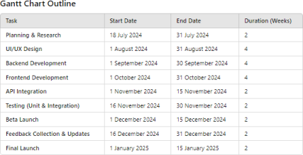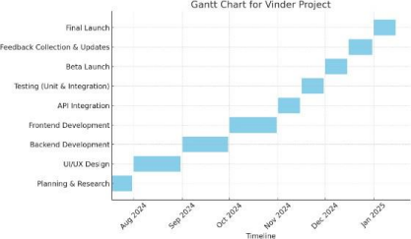

T.Y.B.Sc Information Technology Semester V Anshuka Ravindra Mahagaonkar 757 29 | Page

**b. Pert Chart**

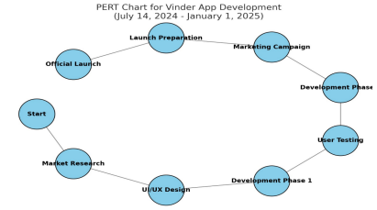**5. Preliminary Product Description**

Preliminary product description helps in identifying the requirements and the objectives of the new proposed product/project/system. It helps in defining the functions and associated activities or operations of the proposed product/project/system.

Vinder is a weekend planning app designed to streamline leisure planning by providing personalized recommendations for users based on their preferences and location. The app aims to offer a convenient, efficient, and enjoyable experience for users to discover and book activities such as restaurants, parks, arcades, and movie theaters. By integrating booking and reservation features and allowing users to plan up to a week in advance, Vinder simplifies the process of organizing weekend activities.

The key requirements of Vinder include providing personalized recommendations, integrating booking and reservation systems, ensuring a user-friendly interface, and offering detailed venue information with user reviews. The app must be compatible with Android platforms, ensure data security, and be scalable to accommodate future growth and new features. Additionally, it requires efficient front-end (React.js) and back-end (Node.js) technologies to ensure a seamless, responsive experience.

T.Y.B.Sc Information Technology Semester V Anshuka Ravindra Mahagaonkar 757 30 | Page

**6. Conceptual Model**

**a. Process Model**

Process models are processes of the same nature that are classified together into a model. Thus, a process model is a description of a process at the type level. One possible use of a process model is to prescribe how things must/should/could be done in contrast to the process itself which is really what happens

**Proposed Process Model**

**i.** Name of Process Model: **Agile Model**

ii. Brief overview of the process model :The Agile process model

focuses on iterative development, where features of the system are

developed incrementallyin short cycles called **sprints**. Each sprint is

designed to produce a working product that can be tested, reviewed,

and improved, allowing flexibility in addressing changing

requirements.

iii. Design of the process model :

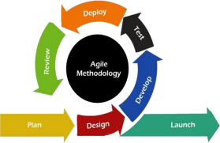

T.Y.B.Sc Information Technology Semester V Anshuka Ravindra Mahagaonkar 757 31 | Page

iv. Reasons for choosing this process model :

The Agile model is ideal for **Vinder** because

It allows for continuous feedback and adjustments based on user needs.

New features and changes can be quickly implemented without overhauling the

entire system.

It promotes close collaboration with users and stakeholders, ensuring that the app

meets their requirements effectively.Application of chosen process model.

v. Application of chosen process model

1) Advantages of chosen process model:

a) Flexibility: Changes can be introduced at any stage of development.

b) Continuous Feedback: Improves the final product by regularly incorporating user input. c) Quick Delivery: Produces working versions of the app after each sprint

2) Disadvantages of chosen process model:

a) Less Predictable: The final project scope can evolve, making it harder to predict deadlines or resource requirements.

b) High Collaboration Needs: Requires continuous interaction between developers, stakeholders and users, which may be challenging to manage.

**b. The goals of a process model are to be:**

a. Descriptive : The process model will track the actual flow of how Vinder suggests personalized weekend activities. It will document the interaction between user

preferences, location data, and the app's recommendation system, as well as the

booking process.

b. Prescriptive: The model will define how the app's key features, such as

recommending venues, processing user preferences, and handling bookings,

should be performed. This includes the flow of data from input (user

location/preferences) to output (recommendations/booking confirmation).

c. Explanatory: It will explain the rationale behind key features of Vinder, such as

how personalized recommendations are generated based on user preferences and

location, and how these suggestions improve user convenience for weekend

planning.

T.Y.B.Sc Information Technology Semester V Anshuka Ravindra Mahagaonkar 757 32 | Page

**c. Diagrams to be included in the design phase are as follows:** For IOT-oriented projects, everything needs to be drawn except the ER diagram

T.Y.B.Sc Information Technology Semester V Anshuka Ravindra Mahagaonkar 757 33 | Page

**1. Use case diagram**

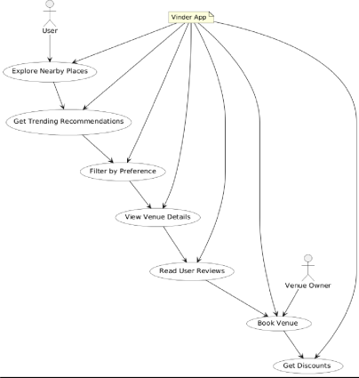

T.Y.B.Sc Information Technology Semester V Anshuka Ravindra Mahagaonkar 757 34 | Page

**2. Activity diagram**

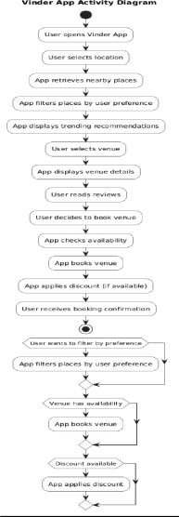

T.Y.B.Sc Information Technology Semester V Anshuka Ravindra Mahagaonkar 757 35 | Page

**3. Class diagram**

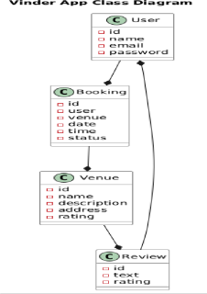

T.Y.B.Sc Information Technology Semester V Anshuka Ravindra Mahagaonkar 757 36 | Page

**4. Sequence diagram**

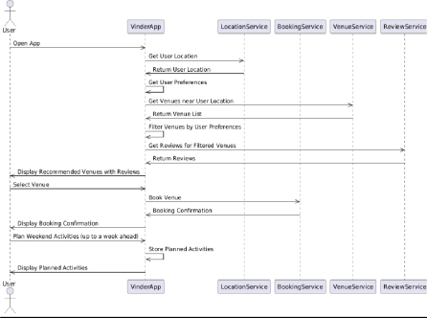

T.Y.B.Sc Information Technology Semester V Anshuka Ravindra Mahagaonkar 757 37 | Page

**5. E-R model**

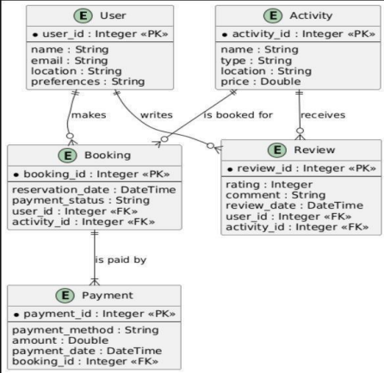

T.Y.B.Sc Information Technology Semester V Anshuka Ravindra Mahagaonkar 757 38 | Page

**6. Data Flow Diagram**

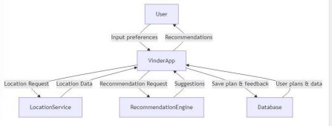

T.Y.B.Sc Information Technology Semester V Anshuka Ravindra Mahagaonkar 757 39 | Page

**CHAPTER 4 : SYSTEM DESIGN**

T.Y.B.Sc Information Technology Semester V Anshuka Ravindra Mahagaonkar 757 40 | Page

**1. Basic Modules**

The **Vinder** app consists of several core modules that work together to provide a seamless weekend planning experience for users. These modules form the backbone of the app's functionality, helping users discover and book activities easily.

**a. Description of Desired Modules**

1.User Profile Module

This module handles user registration, login, and profile management. Users can create an account, update their preferences (e.g., preferred types of activities), and manage their location data for personalized recommendations.

2.Recommendation Engine Module

This is the core module of the app, providing personalized recommendations for places and activities such as restaurants, parks, arcades, and movie theaters. The recommendations are based on user preferences, location, and past behavior.

3. Search and Filter Module

Allows users to search for specific spots or activities and apply filters (e.g., location, type of activity, price range). This module helps users refine their choices and find exactly what they're looking for.

4. Booking and Reservation Module

This module integrates booking features, allowing users to reserve spots at venues (e.g., restaurants, theaters). It provides real-time availability and confirmation of bookings.

5. Review and Rating Module

Users can rate and review the places they've visited. This module stores and displays user feedback to help others make informed decisions about venues.

6. Planner Module

Allows users to plan their weekend activities up to a week in advance. Users can schedule their preferred activities and receive reminders.

T.Y.B.Sc Information Technology Semester V Anshuka Ravindra Mahagaonkar 757 41 | Page

7.Recommendation Engine Module

This is the core module of the app, providing personalized recommendations for places and activities such as restaurants, parks, arcades, and movie theaters. The recommendations are based on user preferences, location, and past behavior.

8. Search and Filter Module

Allows users to search for specific spots or activities and apply filters (e.g., location, type of activity, price range). This module helps users refine their choices and find exactly what they're looking for.

9. Booking and Reservation Module

This module integrates booking features, allowing users to reserve spots at venues (e.g., restaurants, theaters). It provides real-time availability and confirmation of bookings.

10. Review and Rating Module

Users can rate and review the places they've visited. This module stores and displays user feedback to help others make informed decisions about venues. 11. Planner Module

Allows users to plan their weekend activities up to a week in advance. Users can schedule their preferred activities and receive reminders.

T.Y.B.Sc Information Technology Semester V Anshuka Ravindra Mahagaonkar 757 42 | Page

**b. Description of Desired Features**

1. Personalized Suggestions:

Based on user preferences and location, the app provides tailored recommendations for activities and venues.

2.Location-Based Search:

Users can search for places near their current location or input a location to discover activities in a different area.

3.Booking System:

booking and reservations for restaurants, movie theaters, or other venues. Users can secure spots for their chosen activities with a few taps.

4.User Reviews and Ratings:

Users can leave reviews and ratings for places they’ve visited, which will be available for others to view, helping to build trust and a community-driven experience

**2. Data Design**

I. Schema Design

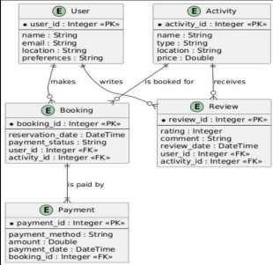

T.Y.B.Sc Information Technology Semester V Anshuka Ravindra Mahagaonkar 757 43 | Page

○ The schema design for the Vinder app involves structuring the database to store

and manage data efficiently. The database is organized into several tables, with

each table representing a key entity in the system.

○ Data Integrity : Data integrity ensures the accuracy, consistency, and reliability of

the data stored in the database. Vinder app's database will implement several

types of data integrity

○ Constraints ; Constraints define rules applied to the database to maintain data quality and ensure that only valid data is entered into the system.

Table description :

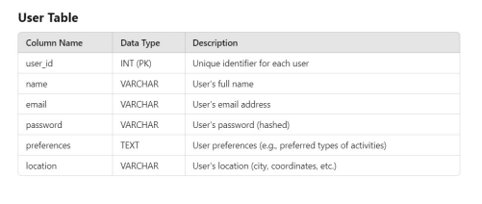

T.Y.B.Sc Information Technology Semester V Anshuka Ravindra Mahagaonkar 757 44 | Page



T.Y.B.Sc Information Technology SemesterV Anshuka Ravindra Mahagaonkar 757 45 | Page



T.Y.B.Sc Information Technology SemesterV Anshuka Ravindra Mahagaonkar 757 46 | Page

**3. Procedural Design**

I. Logic Diagram



II. Data Structures:

• **User Profile**

Purpose**: To store user-specific information and preferences** • **Activity**

**Purpose: To represent an activity or spot in the city.**

• **Booking**

**Purpose**: To store information about user bookings. • **Recommendations**

**Purpose: To provide personalized recommendations for users**

T.Y.B.Sc Information Technology Semester V Anshuka Ravindra Mahagaonkar 757 47 | Page

• **Location**

**Purpose: To store location-related data for activities**

• **Feedback**

**Purpose: To store feedback from users after they participate in activities.**

III. Algorithm design for Vinder App

The Vinder app is designed to recommend personalized activities to users based on their preferenc and location **1.Inputs**

• User preferences (activity types, budget, favorites).

• User location (latitude and longitude).

**2. Processing**

• Fetch user data and nearby activities based on location.

• Filter activities according to user preferences and check availability.

**3. Core Logic**

• Input user preferences and retrieve nearby activities.

• Filter, check availability, and rank activities based on user preferences.

**4. Outputs**

• Recommended activities with booking options.

• Notifications/reminders about selected activities and bookings.

**4. User Interface Design**



T.Y.B.Sc Information Technology Semester V Anshuka Ravindra Mahagaonkar 757 48 | Page

I. Describe the internal and external components of the architecture or user interface II. Draw or frame sample user interface design

**5. Security Issues:**

• Weak Authentication

• Description: Possible unauthorized access due to weak password policies or lack of user authentication

Plan of action:

• Basic Authentication Implementation

• Set up simple user authentication (e.g., username and password) with recommendations for strong password practices.

T.Y.B.Sc Information Technology Semester V Anshuka Ravindra Mahagaonkar 757 49 | Page

**REFERENCES**

T.Y.B.Sc Information Technology Semester V Anshuka Ravindra Mahagaonkar 757 50 | Page

https://developers.google.com/youtube/v3/getting-started https://developers.google.com/youtube/terms/subject-api-service

T.Y.B.Sc Information Technology Semester V Anshuka Ravindra Mahagaonkar 757 51 | Page